# TOPIC : INVESTORS & INVESTMENT DATA ANALYSIS

**insights include:**

* From which countries most investors are from?
* How many investors have investment partners?
* Type of funding round investors are investing in?
* Distribution of investors between Organization and individual person
* Regional Analysis of investors
* Analysis of social media presence of investors
* Qualification (Degree) and Institution Analysis of investors

QUESTION 1: From which countries most investors are from?

QUERY:

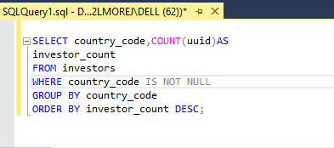

OUTPUT:

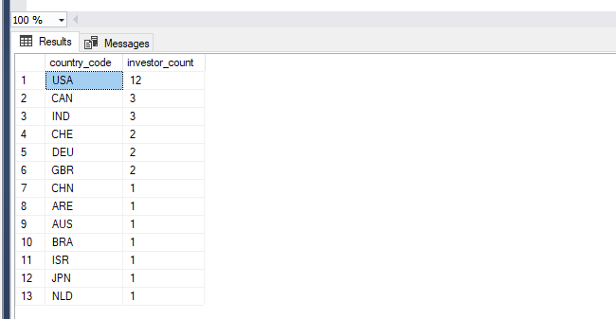

QUESTION 2: How many investors have investment partners?

QUERY & SOLUTION:

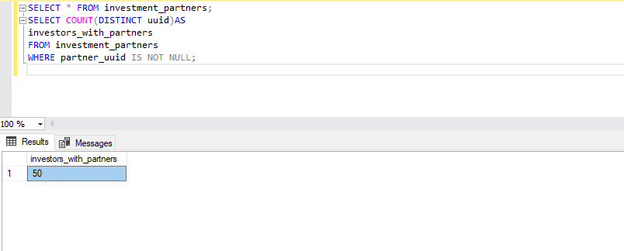

QUESTION 3: Types of funding round investors are investing in?

QUERY:

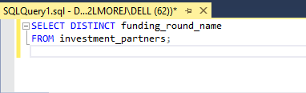

OUTPUT:

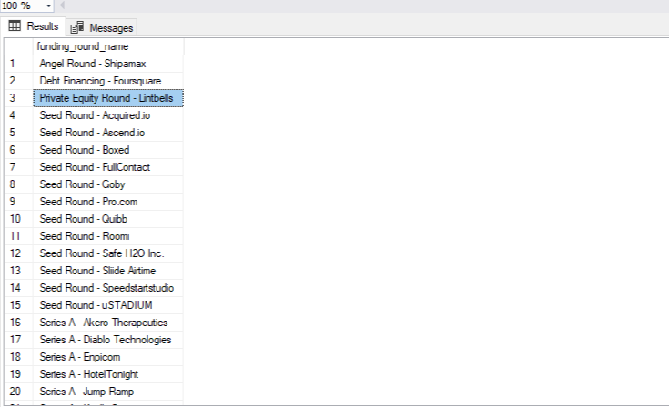

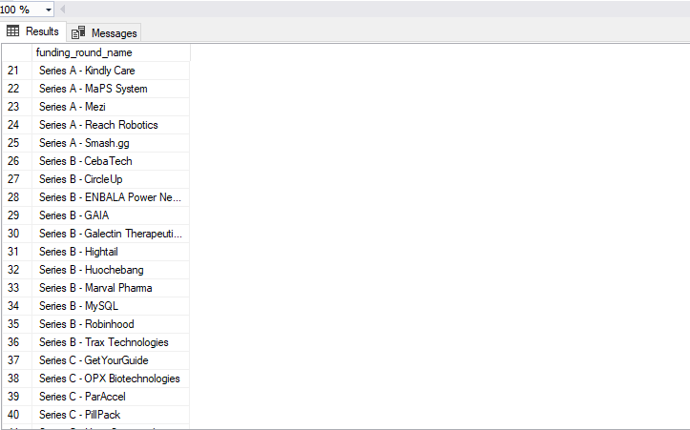

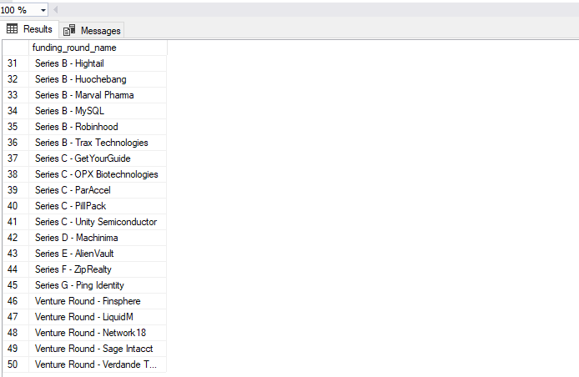

QUESTION 4 : Distribution of investors between Organization and individual person

QUERY & SOLUTION:

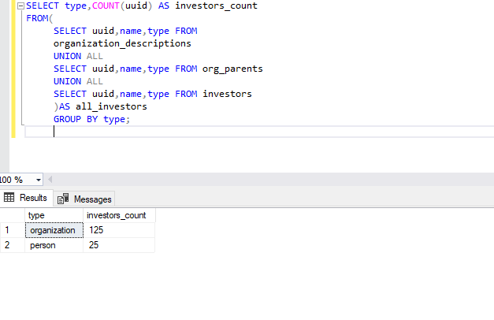

QUESTION 5: Regional Analysis of investors

QUERY:

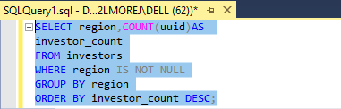

OUTPUT:

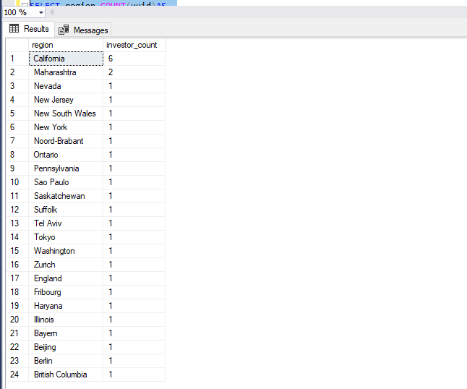

QUESTION 6 : Analysis of social media presence of investors

QUERY 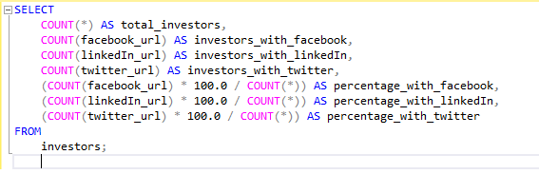

OUTPUT:

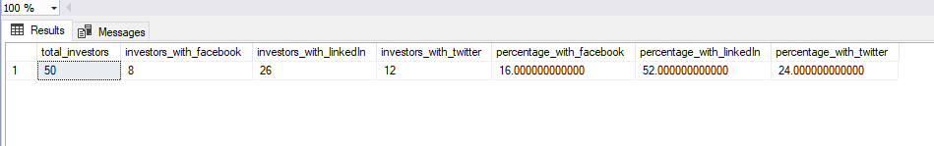QUESTION 7: Qualification (Degree) and Institution Analysis of investors

QUERY:

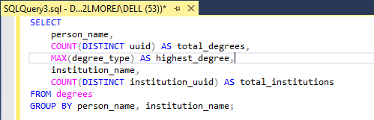

OUTPUT :

